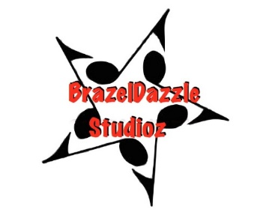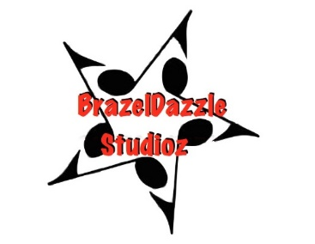
2020 Summer Camp Registration
June 15th-26th Performances June 26th-27th
Student Name: _______________________________________
Date of Birth (child only):__________________________________
Parents Name:__________________________________________
Street Address: _________________________________________
City:______________________________ Zip:_________________
Home phone:______________________
Cell phone: _______________________ Child (if applicable)__________________________
email:____________________________ Child (if applicable)__________________________
Medical Alert:_________________________________________________________________
Registration fee: $25
Tuition: $200.00
T-Shirt Size_______
Camp is from 1:00-4:00 June 15th-19th and 10:00-4:00 June 22nd-26th with public performances Friday June26th & Saturday June 27th
Release of Liability
I understand that my participation or that of my child, in the activities at BrazelDazzle Studioz is optional. I assume all risk of injury for myself or my child(ren), and hereby waive any and all claims which may arise against BrazelDazzle Studioz, Sheri Brazelton or independent contractors from any injury or ailment directly or indirectly related to me or my child(ren) participating in the activities of BrazelDazzle Studioz. I acknowledge that neither BrazelDazzle Studioz, it's owners nor independent contractors are licensed medical practitioners. In the event of a medical emergency, every effort will be made to reach parents immediately; if unable to reach you, this authorizes BrazelDazzle Studioz to call 911.
____ Initials
Photo/Media Release
I hereby grant BrazelDazzle Studioz the right to use the name and image of the student in all forms and in all media manners, for marketing, advertising, or other lawful purposes. The undersigned hereby waives any right to inspect or approve the finished versions before any such use.
___Yes ___No
Your signature below denotes your understanding and acceptance of all the above stated policies and conditions.
_________________________________________________ ___________
Parent Signature/Date
BrazelDazzle Studioz Hendersonville, TN 37075 | 615-447-8228

